Lesson 2 - Guess the Number

***What we gonna learn?***

* Control Flow (While, For loop)
* String concatenation
* Type Conversion
* Counter
* New Line

*Now let’s start coding!!!*

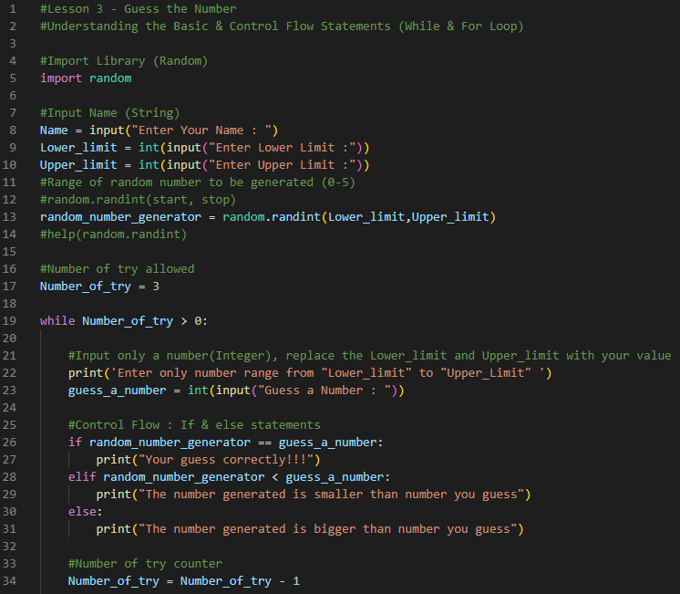

Expected Output :

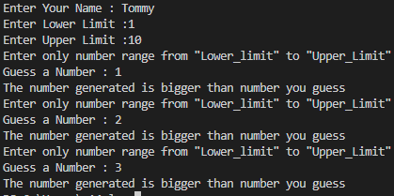

Code Explanation:

1. Comments are written with # at the front (Line 1,2,4,7,11,12,14,16,21,25,33)
2. Line 5 – to import random library (python built in library)
3. Line 8 – Requesting user to input name (the datatype will be string by default)
4. Line 9 & 10 – Requesting the game master to enter lower limit(a) and upper limit(b) of value in the random.randint library.
5. Line 13 – Here is where we use the random library. Other than random.randint(a,b) ,(*a is the lower limit, b is the upper limit, and both will be included in the number generated*) there are more to it. For details [Python Random Module (w3schools.com)](https://www.w3schools.com/python/module_random.asp)
6. Line 17 – Counter for number of try available
7. Line 19 – While loop (One of the control flow available) [Python While Loops (w3schools.com)](https://www.w3schools.com/python/python_while_loops.asp)

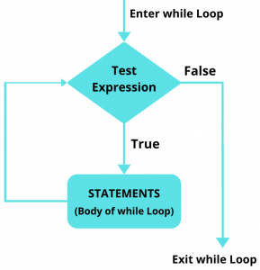

1. Line 22 & 23 – Guide the user on the number that can be entered and ask user to enter the guess number.
2. Line 26 to 31- If *guess_a_number* is the same as *random_number_generator* (It will output line 27), else if *random_number_generated* less than *guess_a_number* (line 29 will be outputted), else if *random_number_generated* greater than *guess_a_number* (line 31 will be outputted)
3. Line 34 – Number of try available (Maximum 3)

Let’s try….

1. After Line 34, try to display the output of Number_of_try available (*Tips: to display an output, we need to use print. For statement, we will use print(“Statement”), but for variable we can just print(variable) without the apostrophe) (Try to display statement+variable in single line, use “+” in between [Check the type of Number_of_try variable and change it to string by using str(variable))*
2. After few trial, you will realize that the program continues to ask you input number to guess although you answered correctly, how should we make it stop if the answer is correct? (*Tips: Line 26 & 27 is for when the answer is correct, add new line after line 27, use either break, continue or pass based on the statement below*)

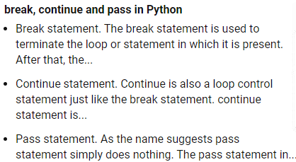

1. After done with no 1 & 2, you will realize that there is no space between your output (after number_of_try) and it is hard to see. Try to make one empty space between each guess. (Tips: use \n at the end of your print(statement+variable(put \n here)). \n mean newline, you can also use print(“ “) at the last line.)
2. Even after you give instruction on 

There are still people entered number that is out of range. To prevent this, use not in range statement with if and see the difference.

(*Tips:*







)



Things to ponder…..

1. What if you print different type of item in one line? Eg. Print(integer+string+string), what will happen?
2. What will happen if in line 34, your put the “Number_of_Try = …..” in the same line as “While”?